**“Simulation and Mathematical Modelling**

**of Vector Control Drive and Associated Parameters”**

A Dissertation submitted in partial fulfilment of the requirement for the award of the Degree of

Bachelor of Engineering In

Electrical Engineering

Submitted by

Prateek Sharma (2K8/EE/853)

Sahil Bhagat (2K8/EE/862)

Saurabh Gupta (2K8/EE/867)



Under the guidance of

Prof. Pramod Kumar

(Professor EED)

Ms Priya Mahajan

(Assistant Professor, EED)

Dr. Rachana Garg

(Associate Professor, EED)

Department of Electrical Engineering

Delhi College of Engineering

University of Delhi

MAY 2012

DELHI COLLEGE OF ENGINEERING



CERTIFICATE

This is to certify that the dissertation entitled “**Simulation and Mathematical Modelling of Vector Control Drive and Associated Parameters**” is submitted by

1. Prateek Sharma (2K8/EE/853)
2. Sahil Bhagat (2K8/EE/862)
3. Saurabh Gupta (2K8/EE/867)

In partial fulfilment for the award of “Bachelor of Engineering Degree in Electrical Engineering” in Delhi College Of Engineering, Delhi University, Delhi is the original work carried out by them under my guidance and supervision. The matter contained in this thesis has not been submitted elsewhere for award of any other degree.

I am pleased with their work and wish them all the best.

Prof. Pramod Kumar Ms. Priya Mahajan Dr. Rachana Garg Dept. of Electrical Engineering

Delhi College of Engineering

**Acknowledgement**

The authors consider it a pleasant duty to record their profound sense of gratitude and ineptness to their project guide Professor Pramod Kumar, Ms. Priya Mahajan, Dr. Rachana Garg, Department of Electrical Engineering, Delhi College of Engineering, Delhi, for his invaluable support and guidance and untiring interest during each and every phase of this project. He has been an invaluable source of motivation and encouragement throughout the course of project.

We extend our thanks to Professor Narender Kumar, Head of the Department, Electrical Engineering for his persistent effort in mobilizing the resources and support at our hand without which the project would not have sailed properly. We owe a sincere thanks to him.

Prateek Sharma (2K8/EE/853)

Sahil Bhagat (2K8/EE/862) Saurabh Gupta (2K8/EE/867)

Department Of Electrical Engineering

Delhi College of Engineering

University of Delhi

**Abstract**

**Topic : Simulation and Mathematical Modelling**

**of Vector Control Drive and Associated Parameters**

By:

**Prateek Sharma 2k8/EE/853**

**Sahil Bhagat 2k8/EE/862**

**Saurabh Gupta 2k8/EE/867**

Our project aims to study the various aspects involved in the controlling of traction systems used in modern railways powered by electricity. This study will cover the various nuances of the system ranging from catenary, transformer, converter, inverter, induction motor and finally the control of induction motor using **Field Oriented Control** or **Vector Control**. We aim to achieve the mathematical model of the whole traction system by separating the components and studying them individually and provide simulated results using **SIMULINK**.

Signature of Mentor,

**Prof Priya Mahajan Dr. Rachana Garg Prof. Pramod Kumar**

**Table of Contents**

1. Acknowledgement
2. Certification
3. Abstract
4. Introduction
5. Theoretical Background

5.1 Vector Control Principles

5.2 Direct Vector Control

5.3 Indirect Vector Control

1. Mathematical Modelling
   1. Catenary
   2. Transformer
   3. Inverter
   4. Motor
2. Simulation of Indirect Vector Control
3. Result
4. Calculation Parameters
5. Conclusion
6. References

**Introduction**

Major improvements in modern industrial processes over the past 50 years can be largely attributed to advances in variable speed motor drives. Prior to the 1950’s most factories used DC motors because three phase induction motors could only be operated at one frequency. Now thanks to advances in power electronic devices and the advent of DSP technology fast, reliable and cost effective control of induction motors is now common place. In 1997 it was estimated that 67% of electrical energy in the UK was converted to mechanical energy for utilization. At the same time the motor drive market in Europe was in excess of one billion pounds. The increase in the use of induction motors was largely attributed to major oil and mining companies converting existing diesel and gas powered machinery to run off electricity. Over the past five years however, the area of AC motor control has continued to expand because induction motors are excellent candidates for use in Electric or Hybrid Electric Vehicles. In this application high performance control schemes are essential.

Over the past two decades a great deal of work has been done into techniques such as Field Oriented Control, Direct Torque Control and Space Vector Pulse Width Modulation. Another emerging area of research involves the application of sensorless control. This differs from conventional methods because it doesn’t require mechanical speed or position sensors. Removing these sensors provides a number of advantages such as lower production costs, reduced size and elimination of excess cabling. Sensorless drives are also more suitable for harsh inaccessible environments as they require less maintenance. This undergraduate thesis thoroughly investigated the aforementioned techniques and used them to develop a Field Oriented Control Scheme for use in an Electric Vehicle.

As part of this thesis, current advances in motor control hardware and Indirect Vector Control techniques were investigated and a thorough mathematical analysis of the subject was also carried out. Some of high performance control schemes were evaluated and the feasibility of implementing these control schemes using existing hardware was considered. SIMULINK modelling of the chosen controller was carried out to investigate its dynamic and steady state performance. These simulations also aided in the selection of controller parameters. A hardware and software design to implement the chosen control structures was detailed and a testing procedure for the controller was outlined. Besides, the future direction of this work was detailed to enable the ideas presented in this thesis to be further developed.

**Theoretical Background**

**Vector or Field-Oriented Control**

So far, we have discussed scalar control techniques of voltage-fed and current-fed inverter drives. Scalar control is somewhat simple to implement, but the inherent coupling effect (i.e. both torque and flux are functions of voltage or current frequency) gives sluggish response and the system is easily prone to instability because of higher order (fifth order) system effect. To make it more clear, if, for example, the torque is increased by incrementing the slip (i.e. the frequency), the flux tends to decrease. Note that the flux variation is always sluggish. The flux decrease is then compensated by the sluggish flux control loop feeding in additional voltage. This temporary dipping of flux reduces the torque sensitivity with slip and lengthens the response time. This explanation is also valid for current-fed inverter drives.

The foregoing problems can be solved by vector or field-oriented control. The invention of vector control in the beginning of 1970s, and the demonstration that an induction motor can be controlled like a separately excited de motor, brought a renaissance in the high-performance control of ac drives. Because of de machine-like performance, vector control is also known as decoupling, orthogonal, or trans-vector control. Vector control is applicable to both induction and synchronous motor drives. Undoubtedly vector control and the corresponding feedback signal processing, particularly for modern sensorless vector control, are complex and the use of powerful microcomputer or DSP is mandatory appears that eventually, vector control will oust scalar control, and will be accepted as the industry-standard control for ac drives.

**Advantages of Vector Control:**

* Stable operation with large motors.
* Better performance at current limit with improved slip control.
* Decrease in the losses of the machine.
* Excellent speed control with inherent slip compensation.
* High torque at low speeds.
* Increase in the overall performance of the motor.
* A proven technique that has been used for some time.

**Disadvantages of Vector Control:**

* Relatively low dynamic performance due to the presence of PI current regulator.
* Parameter detuning causes high torque and flux magnitude errors.
* The equipment required for vector control of induction motor is very costly.

**DC Drive Analogy**

Ideally, a vector-controlled induction motor drive operates like a separately excited dc motor drive, as mentioned above. In a dc machine, neglecting the armature reaction effect and field saturation, the developed torque is given by

$$T_{e}=K_{t}'I_{a}I_{f}$$

where Ia =armature current and If= field current. The construction of a dc machine is such the field flux Ψr produced by the current If is perpendicular to the armature flux Ψa, produced by the armature current Ia. These space vectors, which are stationary in space, are orthogonal or decoupled in nature. This means that when torque is controlled by controlling the current Ia , the flux Ψf is not affected and we get the fast transient response and high torque/ampere with the rated Ψf. Because of decoupling, when the field current If is controlled, affects the field flux Ψf only, but not the Ψa flux. Because of the inherent coupling problem, an induction motor cannot generally give such fast response.

DC machine-like performance can also be extended to an induction motor if the machine control is considered in a synchronously rotating reference frame (de- qe), where the sinusoidal variables appear as dc quantities in steady state. In Figure, the induction motor with the inverter and vector control in the front end is shown with two control current inputs, ids* and idq*.**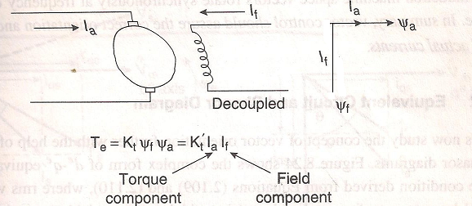Separately Excited dc motor**

These currents are the direct axis component and quadrature axis component of the stator current respectively, in a synchronously rotating reference frame. With vector control, ids is analogous to field current if and iqs is analogous to armature current Ia of a de machine. Therefore, the torque can be expressed as

$$T_{e}=K_{t}Ψ_{r}i_{qs}$$

or

$$T_{e}=K_{t}'i_{ds}i_{qs}$$

where Ψr is the peak value of the sinusoidal space vector.

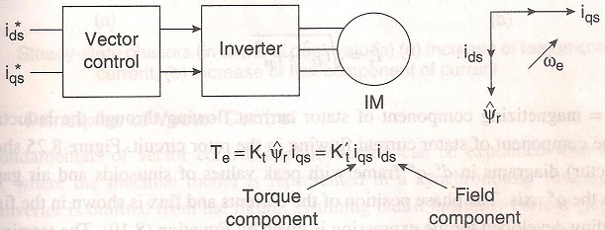

**Vector Controlled Induction motor**

This dc machine-like performance is only possible if ids is oriented (or aligned) in the direction of flux Ψr and iqs is established perpendicular to it, as shown by the space-vector diagram on the right of Figure. This means that when iqs* is controlled, it affects the actual iqs current only, but does not affect the flux Ψr. Similarly, when ids* is controlled, it controls the flux only and does not affect the iqs component of current. This vector or field orientation of current is essential under all operating conditions in a vector-controlled drive. Note that when compared to de machine space vectors, induction machine space vectors rotate synchronously at frequency ωe, as indicated in the figure. In summary, vector control should assure the correct orientation and equality of command and actual currents.

**Equivalent Circuit and Phasor Diagram**

Let us now study the concept of vector orientation further with the help of circuit and phasor diagrams. Figure shows the complex form of de-qe equivalent in steady-state condition derived from Equations, where rms values Vs and Is are replaced by corresponding peak values (sinusoidal vector variables), as shown. The rotor leakage inductance Llr has been neglected for simplicity, which makes the rotor flux Ψr the same as the air gap flux Ψm. The stator current is can be expressed as

$$I_{s}=\sqrt{{i_{ds}}^{2}+{i_{qs}}^{2}}$$

Where ids = magnetizing component of stator current flowing through the inductance Lm and iqs = torque component of stator current flowing in the rotor circuit. Figure shows the phasor (or vector) diagrams in de-qe frame with peak values of sinusoids and air gap voltage Vm aligned on the qe axis.

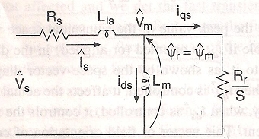

**Complex (qds) equivalent circuit in steady state**

The phase position of the currents and flux is shown in the figure, and the corresponding developed torque expression is given by Equation. The terminal voltage Vs is slightly leading because of the stator impedance drop. The in-phase or torque component of current iqs contributes active power across the air gap, whereas the reactive or flux component of current ids contributes only reactive power. Figure indicates an increase of the iqs component of the stator current to increase the torque while maintaining the flux Ψr constant, whereas the other one indicates a weakening of the flux by reducing the ids component. Note that although the operation is explained for the steady-state condition, the explanation is also valid for the transient condition in the qds equivalent circuit of figure. After understanding the vector orientation principle, the next question is how to control the ids and iqs components of stator current Is independently with the desired orientation. Instead of considering a cartesian form (ids and iqs) of control, it is also possible to consider control in a polar form (|Is| and θ).

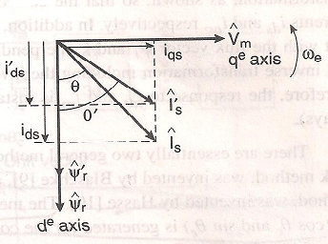

**Increase of flux component of current**

**Principles of Vector Control**

The fundamentals of vector control implementation can be explained with the help of Figure. where the machine model is represented in_ a synchronously rotating reference frame. The inverter is omitted from the figure, assuming that it has unity current gain, that is, it generates currents ia , ib, and ic as dictated by the corresponding command currents ia*, ib*and ic* from the controller. A machine model with internal conversions is shown on the right. The machine terminal phase currents ia , ib, and ic are converted to idss and iqss components by 3Φ/2Φ transformation. These are then converted to synchronously rotating frame by the unit vector components cos θe and sin θe before applying them to the de-qe machine model as shown.

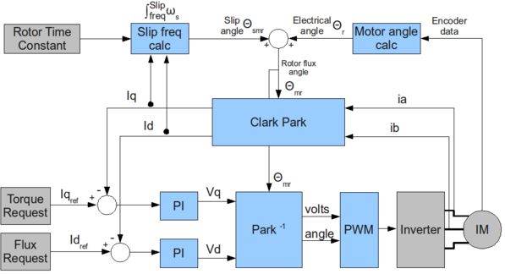

The controller makes two stages of transformation, as shown, so that the control currents ids* and iqs * correspond to the machine currents ids* and iqs * respectively. In addition, the unit vector assures correct alignment of ids current with the flux vector Ψr and iqs perpendicular to it, as shown. Note that the transformation and inverse transformation including the inverter ideally do not incorporate any dynamics and therefore, the response to ids and iqs is instantaneous (neglecting computational and sampling delays). There are essentially two general methods of vector control. One, called the direct or feedback method, was Invented by Blaschke, and the other, known as the indirect or feed forward method, was invented by Hasse. The methods are different essentially by how the unit vector (cos θe and sin θe) is generated for the control. It should be mentioned here that the orientation of ids with rotor flux Ψr air gap flux Ψm or stator flux Ψs is possible in vector control. However, rotor flux orientation gives natural decoupling control, whereas air gap or stator flux orientation gives a coupling effect which has to be compensated by a decoupling compensation current.

**Direct or Feedback Vector Control**

The basic block diagram of the direct vector control method for a PWM voltage-fed inverter drive is shown in Figure. The principal vector control parameters, ids* and iqs* which are de values in synchronously rotating frame, are converted to stationary frame (defined as vector rotation (VR)) with the help of a unit vector (cos θe and sin θe) generated from flux vector signals Ψdrs and Ψqrs. The resulting stationary frame signals are then converted to phase current commands for the inverter. The flux signals Ψdrs and Ψqrs are generated from the machine terminal voltages and currents with the help of the voltage model estimator. A flux control loop has been added for precision control of flux. The torque component of current iqs * is generated from the speed control loop through a bipolar limiter. The torque, proportional to iqs (with constant flux), can be bipolar. It is negative with negative iqs, and correspondingly, the phase position of iqs becomes negative in Figure. An additional torque control loop can be added within the speed loop, if desired. Figure can be extended to field-weakening mode by programming the flux command as a function of speed so that the inverter remains in PWM mode. Vector control by current regulation is lost if the inverter attains the square-wave mode of operation.

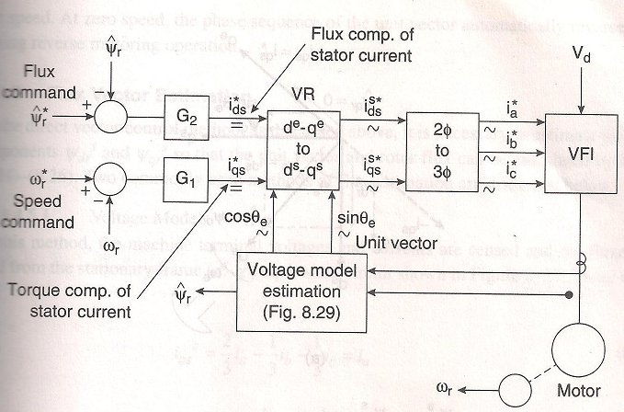

**Direct Vector control block diagram with rotor flux orientation**

The correct alignment of current ids in the direction of flux Ψr and the current iqs perpendicular to it are crucial in vector control. This alignment, with the help of stationary frame rotor flux vectors Ψdrs and Ψqrs, is explained in Figure. In this figure, the de-qe frame is rotating at synchronous speed ωe with respect to stationary frame ds-qs ,and at any instant, the angular position of the de-axis with respect to the ds-axis is θe, where θe = ωet. From the figure write the following equations:

$$Ψ_{dr}^{s}=Ψ_{r}\cos{θ_{e}}$$

$$Ψ_{qr}^{s}=Ψ_{r}\sin{θ_{e}}$$

In other words,

$$\cos{θ_{e}=\frac{Ψ_{dr}^{s}}{Ψ_{r}}}$$

$$\sin{θ_{e}=\frac{Ψ_{qr}^{s}}{Ψ_{r}}}$$

$$Ψ_{r}=\sqrt{{Ψ_{dr}^{s}}^{2}+{Ψ_{qr}^{s}}^{2}}$$

where vector Ψr is represented by magnitude Ψr. Signals cos θe and sin θe have been plotted in correct phase position in Figure. These unit vector signals, when used for vector rotation in figure, give a ride of current ids on the de-axis (direction of Vr) and current iqs on the qe axis as shown. At this condition, Ψqr = 0 and Ψdr = Ψr, as indicated in the figure, and the corresponding torque expression is given by Equation like a dc machine. When the iqs polarity is reversed by the speed loop, the iqs position in Figure also reverses, giving negative torque. The generation of a unit vector signal from feedback flux vectors gives the name “direct vector control”.

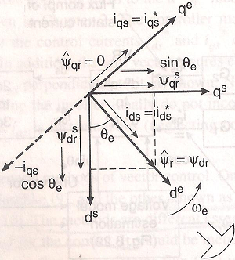

**ds-qs and de-qe phasors showing correct rotor flux orientation**

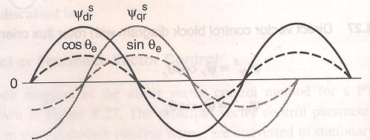

**Plot of unit vector signals in correct phase position**

Summarization of a few salient features of vector control:

• The frequency ωe of the drive is not directly controlled as in scalar control. The machine is essentially "self-controlled," where the frequency as well as the phase is controlled indirectly with the help of the unit vector.

• There is no fear of an instability problem by crossing the operating point beyond the breakdown torque Tem as in a scalar control. Limiting the total $I_{s}\left(\sqrt{{i_{ds}}^{2}+{i_{qs}}^{2}}\right)$ within the safe limit automatically limits operation within the stable region.

• The transient response will be fast and dc machine-like because torque control by iqs does not affect the flux. However, note that ideal vector control is impossible in practice because of delays in converter and signal processing and the parameter variation effect.

• Like a dc machine, speed control is possible in four quadrants without any additional control elements (like phase sequence reversing). In forward motoring condition, if the torque Te is negative, the drive initially goes into regenerative braking mode, which slows down the speed. At zero speed, the phase sequence of the unit vector automatically reverses, giving reverse motoring operation.

**Indirect or Feed forward Vector Control**

The indirect vector control method is essentially the same as direct vector control, except the unit vector signals (cos θe and sinθe) are generated in feed forward manner. Indirect vector control is very popular in industrial applications. The fundamental principle of indirect vector control with the help of a phasor diagram. The ds-qs axes are fixed on the stator, but the dr-qr axes, which are fixed on the rotor, are moving at speed ωr as shown. Synchronously rotating axes de-qe are rotating ahead of the dr-qr axes by the positive slip angle θsl corresponding to slip frequency ωsl. Since the rotor pole is directed on the de axis and ωe =ωr+ωsl, we can write

$$θ_{e}=\int{ω_{e}dt=\int{\left(ω_{r}+ω_{sl}\right)dt=θ_{r}+θ_{sl}}}$$

Note that the rotor pole position is not absolute, but is slipping with respect to the rotor at a frequency ωsl. The phasor diagram suggests that for decoupling control, the stator flux component of current ids should be aligned on the de axis, and the torque component of current iqs should be on the qe axis, as shown.

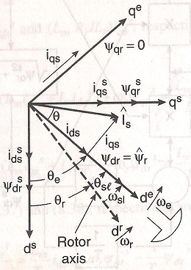

**Phasor diagram explaining indirect vector control**

For decoupling control, we can now make a derivation of control equations of indirect vector control with the help of de-qe equivalent circuits .The rotor circuit equations can be written as

$$\frac{dΨ_{dr}}{dt}+R_{r}i_{dr}+\left(ω_{e}-ω_{r}\right)Ψ_{qr}=0$$

$$\frac{dΨ_{qr}}{dt}+R_{r}i_{qr}+\left(ω_{e}-ω_{r}\right)Ψ_{dr}=0$$

The rotor flux linkage expression can be given as

$$Ψ_{dr}=L_{r}i_{dr}+L_{m}i_{ds}$$

$$Ψ_{qr}=L_{r}i_{qr}+L_{m}i_{qs}$$

From the above equation we can write

$$i_{dr}=\frac{1}{L_{r}}Ψ_{dr}-\frac{L_{m}}{L_{r}}i_{ds}$$

$$i_{qr}=\frac{1}{L_{r}}Ψ_{qr}-\frac{L_{m}}{L_{r}}i_{qs}$$

The rotor currents in above equations which are inaccessible, can be eliminated with the help of other equations as

$$\frac{dΨ_{dr}}{dt}+\frac{R_{r}}{L_{r}}Ψ_{dr}-\frac{L_{m}}{L_{r}}R_{r}i_{ds}-ω_{sl}Ψ_{qr}=0$$

$$\frac{dΨ_{qr}}{dt}+\frac{R_{r}}{L_{r}}Ψ_{qr}-\frac{L_{m}}{L_{r}}R_{r}i_{qs}-ω_{sl}Ψ_{dr}=0$$

For decoupling control it is desired that

$$Ψ_{qr}=0$$

that is

$$\frac{dΨ_{qr}}{dt}=0$$

so that the rotor flux Ψr is directed on the de axis.

Substituting the above equations in equations, we get

$$\frac{L_{r}}{R_{r}}\frac{dΨ_{r}}{dt}+Ψ_{r}=L_{m}i_{ds}$$

$$ω_{sl}=\frac{L_{m}R_{r}}{Ψ_{r}L_{r}}i_{qs}$$

where Ψr = Ψdr has been substituted.

If rotor flux Ψr = constant, which is usually the case, then from equation

$$Ψ_{r}=L_{m}i_{ds}$$

In other words, the rotor flux is directly proportional to current ids in steady state.

To implement the indirect vector control strategy, it is necessary to take relevant equations into consideration. Figure shows a four-quadrant position servo system using the indirect vector control method. The power circuit consists of a front-end diode rectifier and a PWM inverter with a dynamic brake in the dc link. A hysteresis-band current control PWM is shown, but synchronous current control voltage PWM can also be used. The speed control loop generates the torque component of current iqs*, as usual. The flux component of current ids* for the desired rotor flux Ψr is determined from Equation and is maintained constant here in the open loop manner for simplicity. The variation of magnetizing inductance Lm will cause some drift in the flux. The slip frequency WsJ *is generated from iqs* in feedforward manner from Equation to satisfy the phasor diagram in Figure. The corresponding expression of slip gain Ks is given as

$$K_{s}=\frac{ω_{sl}^{*}}{i_{qs}^{*}}=\frac{L_{m}R_{r}}{L_{r}Ψ_{r}}$$

Signal ωsl * is added with speed signal ωr to generate frequency signal ωe· The unit vector signals cosθe and sinθe are then generated from ωe by integration and look-up tables as indicated in the figure. The VR and 2𝛷/3𝛷 transformation are the same as in figure. The speed signal from an incremental-position encoder is mandatory in indirect vector control because the slip signal locates the pole with respect to the rotor dr axis in feed forward manner, which is moving at speed ωr. An absolute pole position on the rotor is not required in this case like a synchronous motor. If the polarity of iqs* becomes negative for negative torque. The phasor iqs in Figure will be reversed, and correspondingly, wsl will be negative (i.e θsl is negative), which will shift the rotor pole position (de axis) below the dr axis. The speed control range in indirect vector control can easily be extended from stand-still (zero speed) to the field weakening region. The addition of field-weakening the dotted block diagram and the corresponding operation is explained in Figure. In this case, close loop flux control is necessary. In the constant torque region, the flux is constant. However, in the field weakening region, the flux is programmed such that the inverter always operates in PWM mode, as explained before. The Joss of torque and power for field-weakening vector control are indicated in the figure. The same principle of field-weakening control is also valid for direct vector control in Figure.

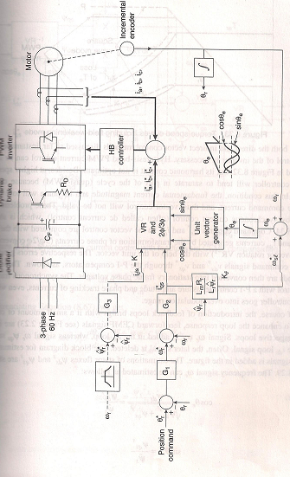**Indirect Vector control block diagram with open loop flux control**

In both the direct and indirect vector control methods discussed so far, instantaneous current control of the inverter is necessary. Hysteresis-band PWM current control can be used as indicated in Figure, but its harmonic content is not optimum. Besides, at higher speeds the current controller will tend to saturate in part of the cycle (quasi-PWM) because of higher CEMF. In this condition, the fundamental current magnitude and its phase will lose tracking with the command current, and thus, vector control will not be valid. These problems can be solved by synchronous current control (often called dc current control), which is shown in figure Figure 8.34. Command currents ids* and iqs* in the vector control are compared with the respective ids and iqs currents generated by the transformation of phase currents (3Φ/2 Φ conversions and inverse vector rotation VR-1) with the help of the unit vector. The respective errors generate the voltage command signals vds *and vqs *through the P-I compensators, as shown. These voltage commands are then converted into stationary frame phase voltages. The synchronous frame current control with a P-I controller assure amplitude and phase tracking of currents, even when the PWM controller goes into over modulation range.

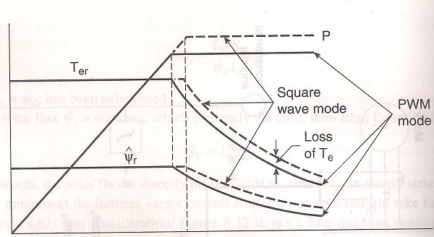

**Torque-speed curves including field weakening modes**

Of course, the introduction of feedback loops brings with it a small amount of coupling effect. To enhance the loop response, feedforward CEMF signals are injected in the respective loops. Signal we lflds is added in the iqs loop, whereas signal ωe  ψds is added in the iqs loop, whereas signal ωe  ψqs subtracts from the ids loop signal. Often, the later signal is deleted. The block diagram for estimating the CEMF signals is added in the figure. The estimations of stator fluxes ψdss and ψqss are shown in figure. The frequency signal ωe can be estimated as follows:

$$\cos{θ_{e}=\frac{Ψ_{ds}^{s}}{\sqrt{{Ψ_{ds}^{s}}^{2}+{Ψ_{qs}^{s}}^{2}}}}=\frac{Ψ_{ds}^{e}}{Ψ_{s}}$$

$$\sin{θ_{e}^{*}=\frac{Ψ_{qs}^{s}}{Ψ_{s}}}$$

$$\tan{θ_{e}^{*}=\frac{Ψ_{q}^{s}}{Ψ_{ds}^{s}}}$$

Differentiating above Equation

$$\sec{{}_{}^{2}{θ_{e} \frac{dθ_{e}^{*}}{dt}}}=\frac{Ψ_{ds}^{s}{\dot{Ψ}}_{qs}^{s}-Ψ_{qs}^{s}{\dot{Ψ}}_{ds}^{s}}{{Ψ_{ds}^{s}}^{2}}$$

where

$$\sec{{}_{}^{2}{θ_{e}= \frac{Ψ_{s}^{2}}{{Ψ_{ds}^{s}}^{2}}}}$$

Substituting Equations, we get

$$ω_{e}=\frac{dθ_{e}}{dt}=\frac{\left(v_{qs}^{s}-i_{ds}^{s}R_{s}\right)Ψ_{ds}^{s}-(v_{ds}^{s}-i_{ds}^{s}R_{s})Ψ_{qs}^{s}}{Ψ_{s}^{2}}$$

where the voltage expressions behind the stator resistance drops have been substituted for the flux derivatives. Frequency we can also be derived as a function of the rotor fluxes by following a similar procedure.

A dc machine-like electro-mechanical model of an ideal vector-controlled drive can be derived using Equation and the following equations:

$$T_{e}=\frac{3}{2}\frac{P}{2}\frac{L_{m}}{L_{r}}Ψ_{r}i_{qs}$$

Figure shows the corresponding transfer function block diagram, where the delay between the command and actual currents has been neglected. The developed torque Te responds instantaneously with the current iqs, but the flux response has first-order delay (with the time constant Lr/Rr), similar to a dc machine. It can be shown that direct -vector control also has a similar transfer function model.

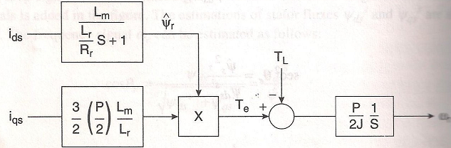

**Transfer function block diagram of vector-controlled drive**

The physical principle of vector control can be understood more clearly with the help of the de -qe circuits shown in Figure. Since currents ids and iqs are being controlled ideally, the stator-side Thevenin impedance is infinity, that is, the stator-side circuit parameters and EMFs are of no consequence. With Ψqr = 0 under all conditions, EMF ωsl/Ψqr = 0 in the de circuit. This indicates that at steady state, current ids will flow through the magnetizing branch only to establish the rotor flux Ψr but transiently, the current will be shared by the rotor circuit also and the time constant can be easily seen as Lr/Rr In the qe circuit, when torque is controlled by iqs EMF ωsl  ψdr in the rotor circuit is modified instantly because ωsl ψdr = Lm Rr iqs/Lr as dictated by Equation.

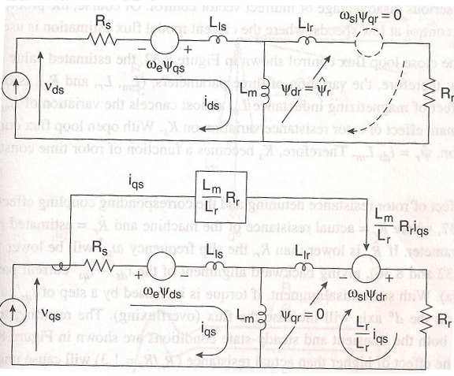

**Explanation of vector control with the help of de-qe circuits**

Since Ψqr = 0, this EMF establishes the current (Lm/Lr)iqs through the resistance Rr.To verify that this current satisfies ψdr = 0, we can write

$${ Ψ}_{qr}=Ψ_{m}+Ψ_{lr}$$

$=L_{m}\left(\frac{L_{m}}{L_{r}}i_{qs}-i_{qs}\right)+\left(\frac{L_{m}}{L_{r}}i_{qs}\right)L_{lr}$

$$=i_{qs}\left(\frac{L_{m}^{2}}{L_{r}}-L_{m}+\frac{L_{m}L_{lr}}{L_{r}}\right)=0$$

If Llr is neglected for simplicity and flux ψr is considered as constant, it can easily be seen that magnetising current component ids flows through Lm only, whereas the torque component of current iqs is constrained to flow to the rotor side only. This was the original hypothesis in explaining vector control with the help of Figures.

**Indirect Vector Control Slip Gain (Ks) Tuning**

The slip gain Ks in indirect vector control is a function of the machine's parameters. It is desirable that these parameters match the actual parameters of the machine at all operating conditions to achieve decoupling control of the machine. The slip gain detuning problem is a serious disadvantage of indirect vector control. Of course, the problem is similar to direct vector control at low speeds, where the current model flux estimation is used.

With the close loop flux control, the estimated value of ψr (input to Ks) is known; therefore, the variation of three parameters, (Lm, Lr, and Rr), is of concern. The saturation effect of magnetizing inductance Lm almost cancels the variation of Lm/Lr , thus leaving the dominant effect of rotor resistance variation on Ks. With open loop flux control at steady state condition, ψr = ids Lm. Therefore, Ks becomes a function of rotor time constant Tr = Lr/Rr only.

The effect of rotor resistance detuning and the corresponding coupling effect are explained in Figure, where Rr =actual resistance of the machine and Rr =estimated resistance used in the Ks parameter. If Rr is lower than Rr the slip frequency ωsl * will be lower than the actual, giving backward alignment of the ids'- iqs' current pair, as shown in Figure. With such misalignment, if torque is increased by a step of iqs', a component of this current on the de axis will increase the flux (overfluxing). The resulting torque and flux responses in both the transient and steady-state conditions are shown in Figure. On the other hand, the effect of higher than actual resistance (Rr/Rr = 1.3) will cause underfluxing.

The initial tuning of slip gain is straightforward if the parameters of the machine are known a-priori. Conversely, an automated measurement of parameters can be made initially by injecting signals in the machine through the inverter and then estimating the parameters with the help of a DSP. This will be discussed later in self-commissioning of the drive. The initial tuning of Ks can also be done by giving a square-wave torque (or iqs *) command and then matching the actual torque wave with the predicted torque wave under a tuned condition.

The continuous on-line tuning of Ks is very complex and demands rigorous computation by a DSP. A number of methods for slip gain tuning have been suggested in the literature. Unfortunately, most of these algorithms are also dependent on machine parameters. Fortunately however the temperature variation of Rr is somewhat slow, and this permits adequate computation time required by the DSP. The extended Kalman filter (EKF) method of parameter or state estimation based on the full-order dynamic machine model is an elegant and powerful method, and it will be discussed later for speed estimation.

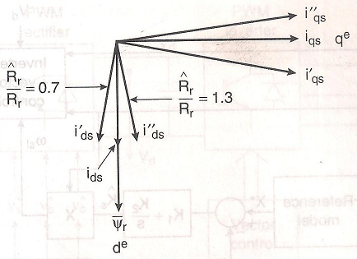

**Vector control detuning due to rotor resistance mismatch**

Another method that is more acceptable is based on the model referencing control (MRAC) and is shown in general block diagram form. Here, the reference model output signal X* that satisfies the tuned vector control is usually a function of command currents ids* and iqs* machine inductances, and operating frequency. The adaptive model X is usually estimated by the machine feedback voltages and currents; as shown. The reference model output is compared with that of the adaptive model and the resulting error generates the estimated slip gain Ksthrough a P-I compensator. Thus, slip gain tuning will occur when X matches with x* Consider for example, on-line tuning based on the torque model. Figure shows the deviation of actual torque from the commanded value because of detuned slip gain.

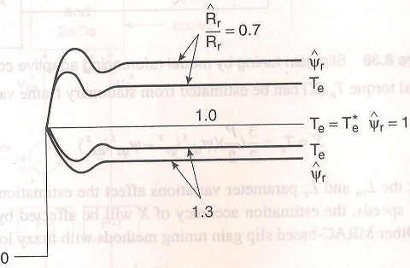

**Resulting Response**

The Ks parameter can be tuned so that Te = Te *at all operating conditions. In Figure , the reference model output for idea vector control is given as

$$X^{*}=T_{e}^{*}=\frac{3}{2}\frac{P}{2}\frac{L_{m}}{L_{r}}Ψ_{r}^{*}i_{qs}^{*}$$

Substituting ψr = Lm ids*, we get

$$X^{*}=\frac{3}{2}\frac{P}{2}\frac{L_{m}^{2}}{L_{r}}i_{ds}^{*}i_{qs}^{*}$$

The actual torque Te (X) can be estimated from stationary frame variables as follows:

$$X=T_{e}=\frac{3}{2}\frac{P}{2}\left(Ψ_{dc}^{s}i_{qs}^{s}-Ψ_{qs}^{s}i_{ds}^{s}\right)$$

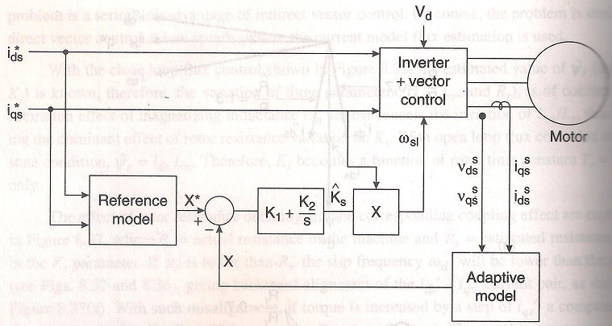

**Slip gain tuning by model referencing adaptive control principle**

Note that the Lm and Lr parameter variations affect the estimation accuracy of X*. Additionally, at low speeds, the estimation accuracy of X will be affected by the variation of stator resistance Rs·

**Clarke’s and Park’s Transformations**

The performance of three-phase ac machines are described by their voltage equations and inductances. It is well known that some machine inductances are functions of rotor speed. The coefficients of the differential equations, which describe the behaviour of these machines, are time varying except when the rotor installed. A change of variables is often used to reduce the complexity of these differential equations. There are several different methods to transform variables. In this chapter, the well-known Clarke and Park transformations are introduced, modelled, and implemented on the LF2407 DSP. Using these transformations, many properties of electric machines can be studied without complexities in the voltage equations. These transformations make it possible for control algorithms to be implemented on the DSP. By this approach, many of the basic concepts and interpretations of this general transformation are concisely established.

**Clarke’s Transformation**

The transformation of stationary circuits to a stationary reference frame was developed by E. Clarke. The stationary two-phase variables of Clarke’s transformation are denoted as α

and β. As shown in Fig. α-axis and β -axis are orthogonal.

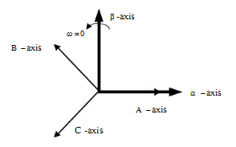

**Clarke’s Transformation**

In order for the transformation to be invertible, a third variable, known as the zero sequence component is added, the resulting transformation is

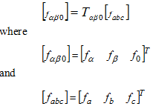

where ƒ represents voltage, current, flux linkages, or electric charge and the transformation matrix, *Tαβ0* , is given by

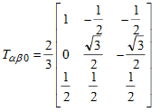

The inverse transformation is given by



Where the transformation matrix is represented by

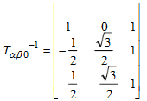

**Park’s Transformation**

In the late 1920s, R.H. Park introduced a new approach to electric machine analysis. He formulated a change of variables which replaced variables such as voltages, currents, and flux linkages associated with fictitious windings rotating with the rotor. He referred the stator and rotor variables to a reference frame fixed on the rotor. From the rotor point of view, all the variables can be observed as constant values. Park’s transformation, a revolution in machine analysis, has the unique property of eliminating all time varying inductances from the voltage equations of three-phase ac machines due to the rotor spinning. Although changes of variables are used in the analysis of ac machines to eliminate time-varying inductances, changes of variables are also employed in the analysis of various static and constant parameters in power system components. Fortunately, all known real transformations for these components are also contained in the transformation to the arbitrary reference frame. The same general transformation used for the stator variables of ac machines serves the rotor variables of induction machines. Park’s transformation is a well-known three-phase to two-phase transformation in synchronous machine analysis. Park’s transformation is presented in the figure below:

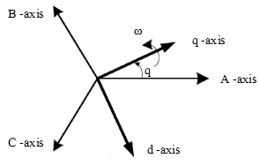

**Park’s Transformation**

The transformation is the form:

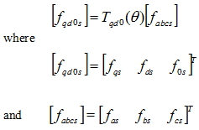

And the dq0 transformation matrix is defined as:

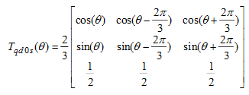

Θ is the angular displacement of Park’s reference frame and is described by:



Where ζ is the dummy variable of integration. It can be shown that for inverse transformations we can write



Where the inverse of Park’s transformation matrix is given by

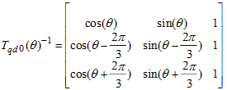

In the previous equations, the angular displacement θ must be continuous but the angular velocity associated with the change of variables is unspecified. The frame of reference may rotate at any constant, varying angular velocity, or it may remain stationary. The angular velocity of the transformation can be chosen arbitrarily to best fit the system equation solution or to satisfy the system constraints. The change of variables may be applied to variables of any wave form and time sequence; however, we will find that the transformation given above is particularly appropriate for an a-b-c sequence.

**Transformations between Reference Frames**

In order to reduce the complexity of some derivations, it is necessary to transform the variables from one reference frame to another one. To establish this transformation between any two reference frames, we can denote *y* as the new reference frame and

*X* as the old reference frame. Both new and old reference frames are shown in Figure.

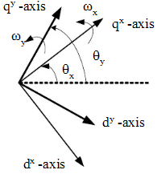

**Transformation between two reference frames**

It is assumed that the reference frame *x* is rotating with angular velocity ω x and the reference frame *y* is spinning with the angular velocity ω y. θ x and θ y are angular displacements of reference frames *x* and *y*, respectively. In this regard, we can rewrite the transformation equation as



But we have



On substitutions we get



In another way we can find out that



So we obtain



The desired transformation can be expressed by following matrix:

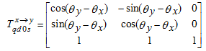

**Field Oriented Control (FOC) Transformations**

In the case of FOC of electric machines, control methods are performed in a two-phase reference frame fixed to the rotor *(qr-dr)* or fixed to the excitation reference frame *(q e-de)*. We want to transform all the variables from the three-phase a-b-c system to the two-phase stationary reference frame and then retransform these variables from the stationary reference frame to a rotary reference frame with arbitrary angular velocity of ω. These transformations are usually cascaded. The block diagram of this procedure is shown in Fig.

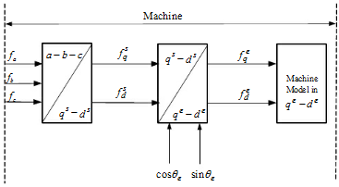

**Machine side transformation in field oriented control**

In this figure, *f* denotes the currents or voltages and *qe-de* represents the arbitrary rotating reference frame with angular velocity ωe and *qs-ds* represents the stationary reference frame. In the vector control method, after applying field-oriented control it is necessary to transform variables to stationary a-b-c system. This can be achieved by taking the inverse transformation of variables from the arbitrary rotating reference frame to the stationary reference frame and then to the a-b-c system. The block diagram of this procedure is shown in Figure. In this block diagram, * is a representation of commanded or desired values of variables.

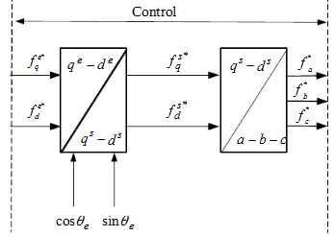

**Variable Transformation in the field oriented control**

**Transformation from 3-phase to 2-phase Stationary Reference Frame**

**(a-b-c)🡪(qs-ds)**

This transformation transfers the three-phase stationary parameters, *fa, fb and fc* from an a-b-c system to a two-phase orthogonal stationary reference frame. If we substitute θ=0 equations and assuming that the system is balanced, we get

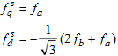

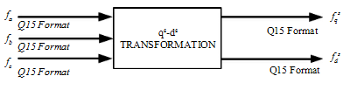

**Two phase stationary transformation**

**Transformation from the Stationary Reference Frame to Arbitrary Rotary Reference Frame (qs-ds)🡪(q-d)**

This transformation converts vectors in a balanced two-phase orthogonal stationary system into an orthogonal rotary reference frame. The inputs are fqs *,*fds and θ and the outputs are fd and fq *.* This is the transformation between the stationary reference frame and the arbitrary reference frame rotating with theangular velocity of ω. If we substitute θx=0 and θy=0, we obtain



where θ is the angular displacement. Accordingly sinθ and cosθ are to be calculated to have the transform.

**Transformation of the Arbitrary Rotating Reference Frame to the Stationary Reference Frame (q-d)🡪(qs-ds)**

This transformation projects vectors in an orthogonal rotating reference frame into a two-phase orthogonal stationary frame. So we get:



Where θ is the angular displacement. Accordingly sinθ and cosθ are to be calculated to have the transform.

**Mathematical Modelling**

**Transfer Functions**

1. **Catenary**

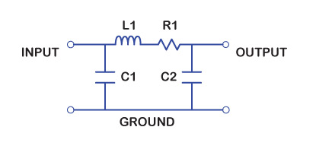

**Pi Model of Transmission Line**

Z1= 1/sC1

Z2= 1/sC2

Z3= R1 + sL1

**VO/Vin = Z2/(Z2 +Z3)**

1. **Transformer**

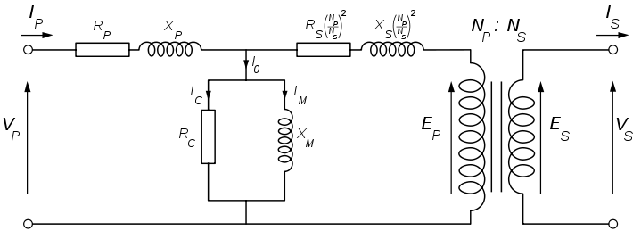

**Equivalent Circuit Diagram of Transformer**

Z1=RP + sXP

Z2=RC||sXM

Z3=RS(NP/NS)2 + sXS(NP/NS)2

Y1 = (Z1 * Z2 + Z1 * Z3 + Z3 * Z2)/ (Z1)

Y2 = (Z1 * Z2 + Z1 * Z3 + Z3 * Z2)/ (Z2)

Y3 = (Z1 * Z2 + Z1 * Z3 + Z3 * Z2)/ (Z3)

**EP(s)/ VP(s) = Y1/ (Y1+Y3)**

1. **Inverter**

For analysis of the dynamic performance of continuous linear system classical methods, based on root locus or bode plot, are very often used. But these methods can’t be directly applied to discrete nonlinear systems, like PWM switching power converters. Methods to establish approximate linear models for power converters will be very beneficial to the power electronic design engineer. These models will provide knowledge to be used for analysis and initial selection of the design parameters. The more exact nonlinear model can then be used in simulation programs to verify the selected design. The popular state-space averaging method is extensively used in DC-to-DC converter analysis(1-5). Applications of this method for analysis of PWM power converters with only one independent PWM signal are reported (6-7). However, application of this method for analysis of converters with more than one independent PWM signals has limitations. Taking blanking time effects into consideration is also difficult when using the state-space averaging method. A basic circuit module which performs the pulse-width modulation mechanism in a PWM converter is the bridge leg. By use of Fourier analysis, an equivalent circuit is developed for the bridge leg. This equivalent circuit is used to model a single-phase inverter. A linear transfer function model is also developed. The bridge leg equivalent circuit and the suggested approach to derive the linear transfer function model provides a new method for power converter modeling in general. Figure shows the physical circuit of the power converter bridge leg. The terminals, **D+ *D.*** are connected to the DC link voltage, and the terminal G, is connected to the AC stage. The positive current directions of the three terminal s are denoted in the diagram.

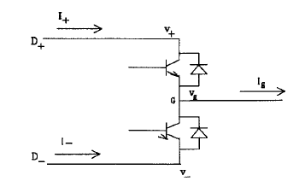

**Physical circuit of power converter bridge leg**

Each terminal is associated by a voltage potential and a current. The upper and lower transistors are complementary controlled, so there is only one independent PWM signal for one bridge leg. The number of variables which are coupled with the bridge leg is seven. By use of the bond graph method, the stimulus response relationship of these variables was found. In Figure, the stimulus variables, which are the action imposed on the bridge leg by its environment, are represented by inputs and the response variables, from the bridge leg to its environment, are represented by outputs.

Mathematically, the bridge leg performs the following functions:

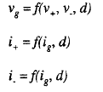

The first equations represents the voltage interaction between the DC link voltage potentials and the PWM signal and the other two equation represent the current interaction between the AC stage current and the PWM signal. These two interactions exist simultaneously. At ideal operation, the bridge leg has two operation states: switch-on state and switch-off state, which are defined by the state of the upper transistor. The operation state is controlled by the PWM signal. It has two functions:

- Clamp **AC** terminal potential ***v8*** to ***v+*** or ***v_***

- Switch AC current i, to upper or lower path.

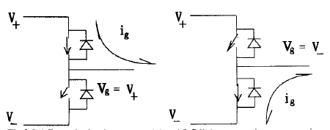

**Response functions**

**DC** link currents in two operation states. The duty ratio ***D(k),*** which is generally used to represent the PWM signal, can be decomposed into a control variable and a fixed offset as:

***D(k)*** = ***d(k)*** + 0.5

where ***k*** represents discrete time. The control variable ***d(k)*** is called the effective duty ratio and the constant number 0.5 is the offset. The duty ratio and the effective duty ratio are discrete-time variables. Due to time-discrete switching of the power transistors, a pure sinusoidal effective duty ratio can’t result in a pure sinusoidal voltage response. In addition to the fundamental frequency response, which has the same frequency as the effective duty ratio, higher order harmonics are generated.

Let the effective duty ratio be a general discrete-time variable. In discrete-time Fourier series. The transmission factor and the deflection factor are functions of the frequency modulation ratio, m,. The most significant transmission factors and deflection factors are calculated and plotted against m,. Here, we only present the fundamental frequency transmission factor and fundamental-to-third harmonic deflection factor,

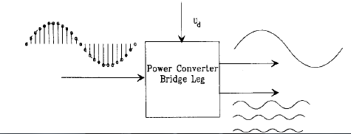

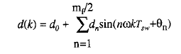

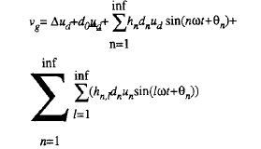

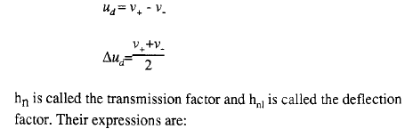

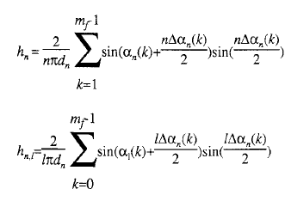

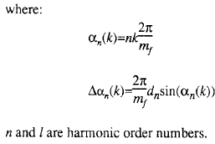

The transmission factor and the deflection factor are functions of the frequency modulation ratio, m,. The most significant transmission factors and deflection factors are calculated

and plotted against m,. Here, we only present the fundamental frequency transmission factor and fundamental-to-third harmonic deflection factor.

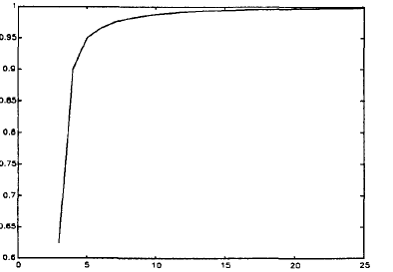

**The fundamental transmission factor hl vs mf**

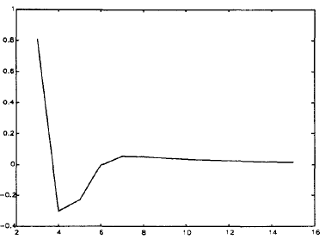

**The fundamental to third harmonic deflection factor hl3 vs mf**

From the above curves, we observe that the transmission factor approaches to unity and the deflection factor approaches to zero when m, increases to infinity. **A** quantitative study of the important transmission factor curves and deflection factor curves concludes that when m,>21, all the important transmission factors are close to unity and the deflection factors are close to zero.

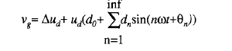

When the switching frequency approaches infinity, the effective duty ratio changes from a discrete-time variable to a continuous time variable.



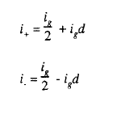

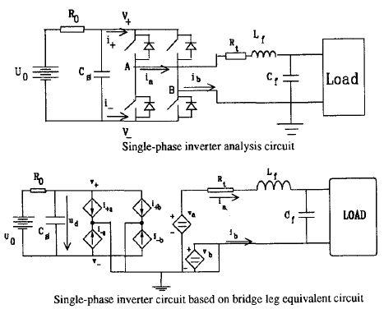

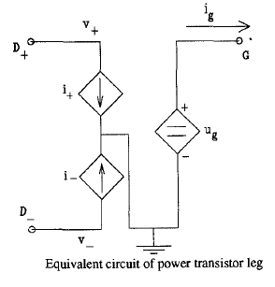

In the equivalent circuit, the voltage and current relations are represented by a dependent voltage source vg and two current dependent sources i, and i-, respectively. We recognize the three terminals from the physical circuit. . In the physical bridge leg circuit, the ground implicitly exits when voltage potentials are used as variables. In order to use voltage instead of voltage potential, an explicit ground is required, which is the case of the equivalent circuit. Both dependent current sources are connected to the ground, because ground is the only source or sink for current. 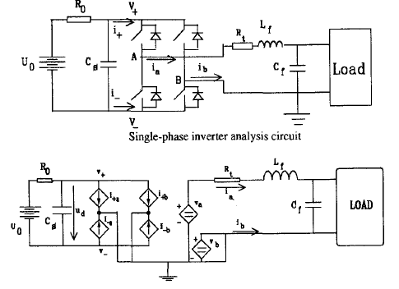

**Single-phase inverter analysis circuit based on bridge leg equivalent circuit**

The expressions for the dependent voltage and current sources can be written according to the derived voltage and current response equations.

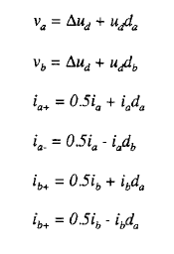

The bridge leg based circuit can be simplified by considering

- The relationship between different PWM signals,

- The relationship between different phase currents,

- The voltage clamped by the ground

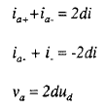

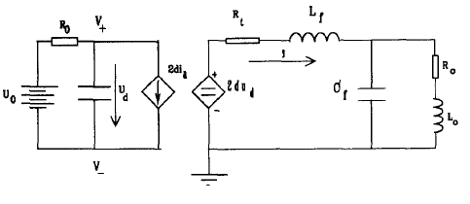

**Equivalent Circuit of Single Phase Inverter**

**(2dVas)(RO-sCf) – 2000dωs(RO-sCf) + 1900(ROH)**

**VO =  (s2+ω2)**

**Vin ((2dVa) – (2dVa(sCf+1)-2000dω(sCfH))(s2+ω2)**

**(s2+ω2) (2dω)**

1. **Motor**

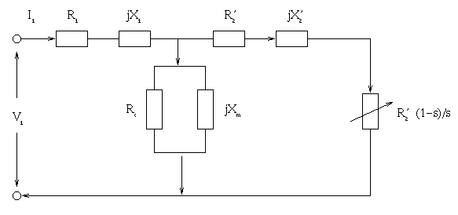

**Equivalent Circuit Diagram of Induction Motor**

**Z1= R1+sX1**

**Z2=R2+sX2**

**Z3=sRcXm/(Rc+sXm)**

Y1 = (Z1 * Z2 + Z1 * Z3 + Z3 * Z2)/ (Z1)

Y2 = (Z1 * Z2 + Z1 * Z3 + Z3 * Z2)/ (Z2)

Y3 = (Z1 * Z2 + Z1 * Z3 + Z3 * Z2)/ (Z3)

**Vo(s)/ V1(s) = Y1/ (Y1+Y3)**

**Simulation of Indirect Vector Control**

The matlab model explained below successfully explains the behaviour of the Induction motor

**Drive:**

Below is the model of an induction motor drive

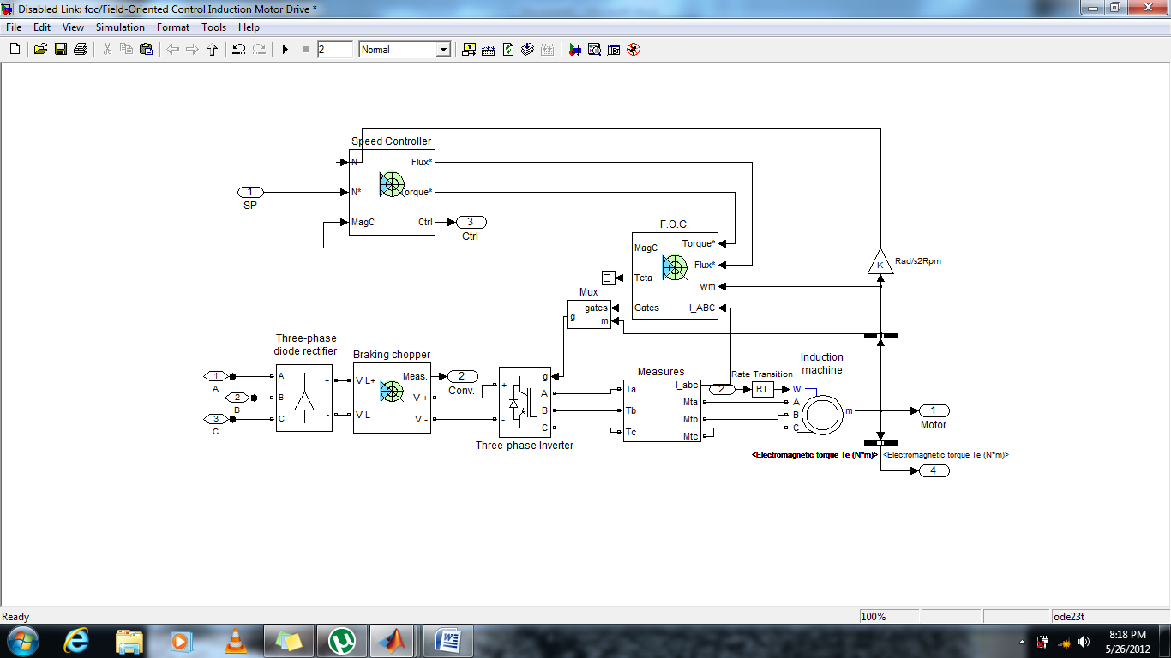

This block has two main components:

1. The speed controller block.
2. The field controller block(foc).

The **Speed Control Block** is given below

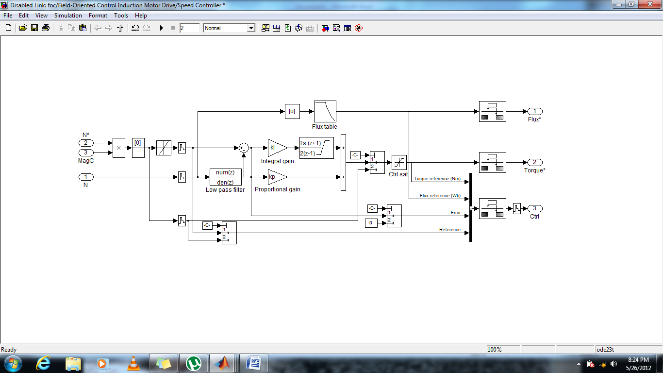

This block works on two main inputs

1. Speed from the motor shaft.
2. Desired speed of operation.

The output of this block is torque and flux which goes as inputs to the foc block.

The **foc block** is as shown below:

This block implements the indirect or feedforward vector control

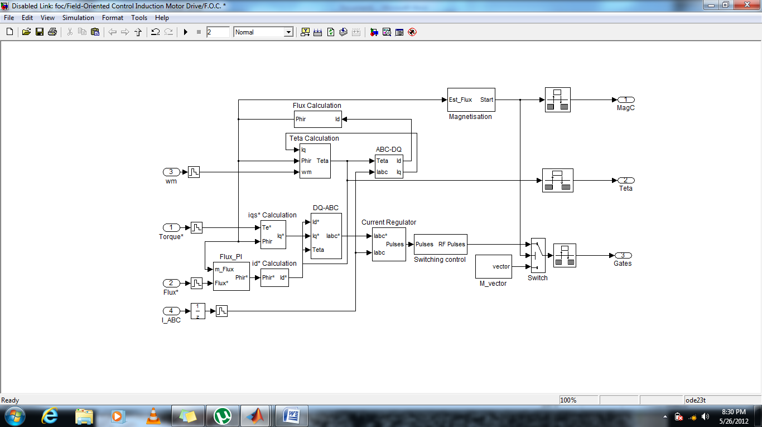

The inputs to this block are as follows.

1. Desired speed of operation in radians per second.
2. Torque from the speed controller block.
3. Flux from the speed controller block.
4. Motor currents Iabc.

The outputs of this block are as follows.

1. Gating signals
2. Magc which is only the signal that confirms or declines the start of the motor.
3. Teta which gives the value of the angle at which the rotor runs.

The gating signals obtained from above goes to the inverter which produces a three phase

Rectangular wave .

Now we wanted to leniarize the feedback system of the drive and simplify the complex feedback system into a simple open loop configuration. This can be achieved for a constant speed operation.

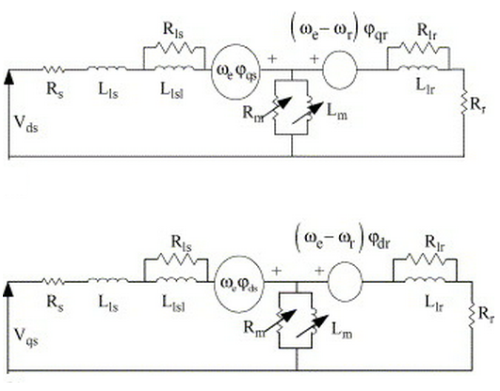

**Dyamic de-qe equivalent matrix of Motor**

$$\begin{matrix}Vqs \\ Vds \\ \begin{matrix}Vqr \\ Vdr\end{matrix}\end{matrix}=\left[\begin{matrix}\begin{matrix}Rs+(sLs) & ωeLs \\ -ωeLs & Rs+sLs\end{matrix} & \begin{matrix}sLm & ωLm \\ -ωeLm & sLm\end{matrix} \\ \begin{matrix}sLm & (ωe-ωr)Lm \\ -\left(ωe-ωr\right)Lm & sLm\end{matrix} & \begin{matrix}Rr+sLr & (ωe-ωr)Lr \\ -\left(ωe-ωr\right)Lr & Rr+sLr\end{matrix}\end{matrix}\right]*\begin{matrix}Iqs \\ Ids \\ \begin{matrix}Iqr \\ Idr\end{matrix}\end{matrix}$$

The above matrix has been derived for a motor rotating at a speed Wr . By solving the above matrix for a given value of voltage (400V) we can obtain the value of current in the rotating frame of reference, with these values of currents namely Ide and Iqe which are the value of currents along the rotating d-q axis frame. After obtaining these values our feedback system simplifies to

1/Ψr Iq*

Te*

2Lr/3PLm

2Lr/3PLm

Id Ψr

We can obtain the values of current using a simple m file

Rs=14.85e-3;   
Ls=0.3027e-3;   
Lr=0.3027e-3;   
Rr=9.259e-3;   
Lm=10.46e-3;   
We=157.08;   
Wr=150.8; % 4%slip   
P=4;   
J=3.1;   
s=tf( 's' );   
a=[400;0;0;0];   
b= [Rs+s*Ls We*Ls s*Lm We*Lm;   
 -We*Ls Rs+s*Ls -We*Lm s*Lm;   
 s*Lm (We-Wr)*Lm Rr+s*Lr (We-Wr)*Lr;   
 -(We-Wr)*Lm s*Lm -(We-Wr)*Lr Rr+s*Lr];

c=b\a

the output of this file is as follows:

Transfer function from input to output...

-1108 s^3 - 3.38e004 s^2 - 4.003e004 s + 3.349e007

#1: -----------------------------------------------------

s^4 - 0.1335 s^3 + 2.471e004 s^2 - 1268 s + 9.756e005

-1.74e005 s^2 - 5.53e006 s - 6.725e006

#2: -----------------------------------------------------

s^4 - 0.1335 s^3 + 2.471e004 s^2 - 1268 s + 9.756e005

3.827e004 s^3 - 2555 s^2 + 1.461e006 s - 1.03e006

#3: -----------------------------------------------------

s^4 - 0.1335 s^3 + 2.471e004 s^2 - 1268 s + 9.756e005

6.012e006 s^2 - 1.48e005 s + 2.374e008

#4: -----------------------------------------------------

s^4 - 0.1335 s^3 + 2.471e004 s^2 - 1268 s + 9.756e005

Substituting all the values in the matlab we obtain the simulink file .

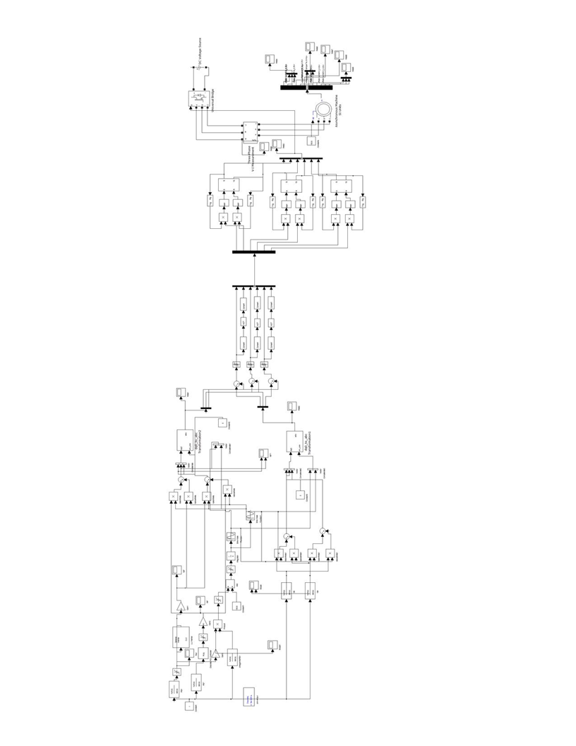

**Results**

The simulation results are as follows:

**Curves for currents Ide and Iqe in rotaing frame without feedback.**

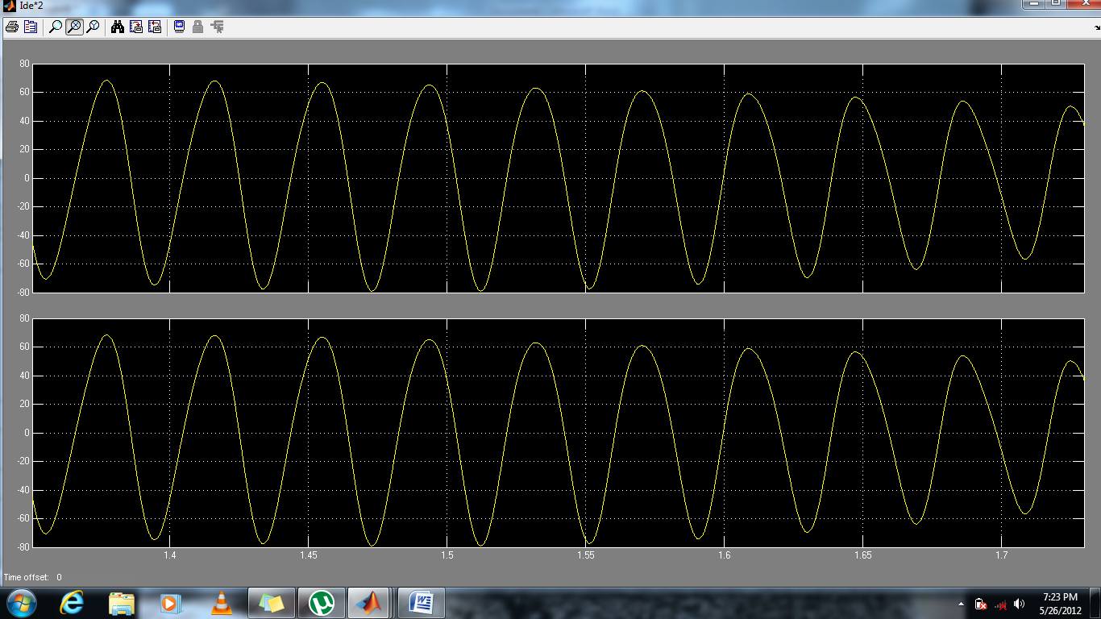

**Curves for current without feedback in stationary frame**

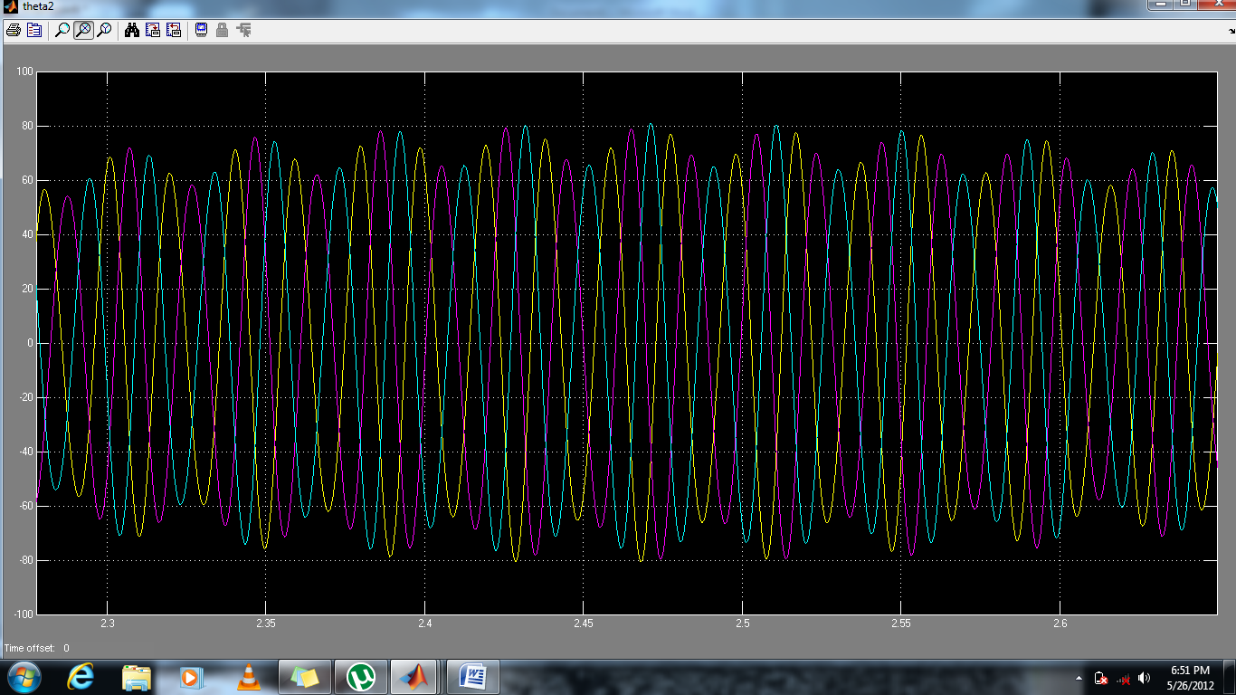

**Curves for rotating frame currents Ide and Iqe after feedback.**

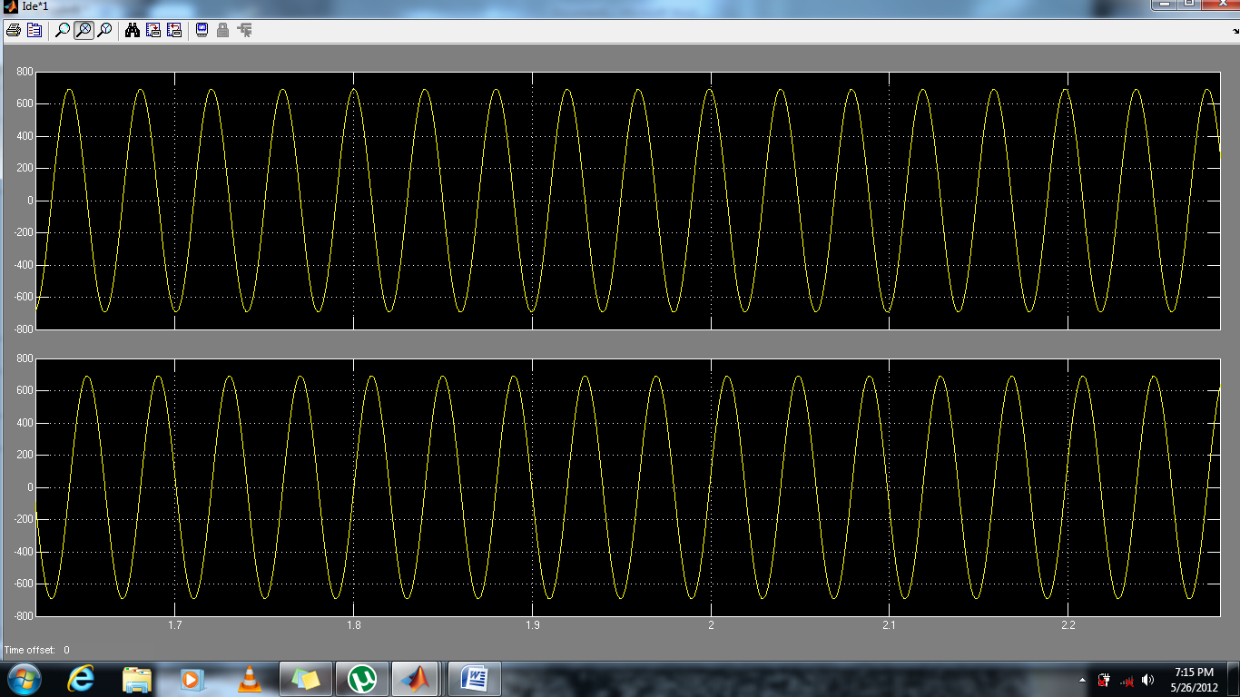

**Curve for current after feedback**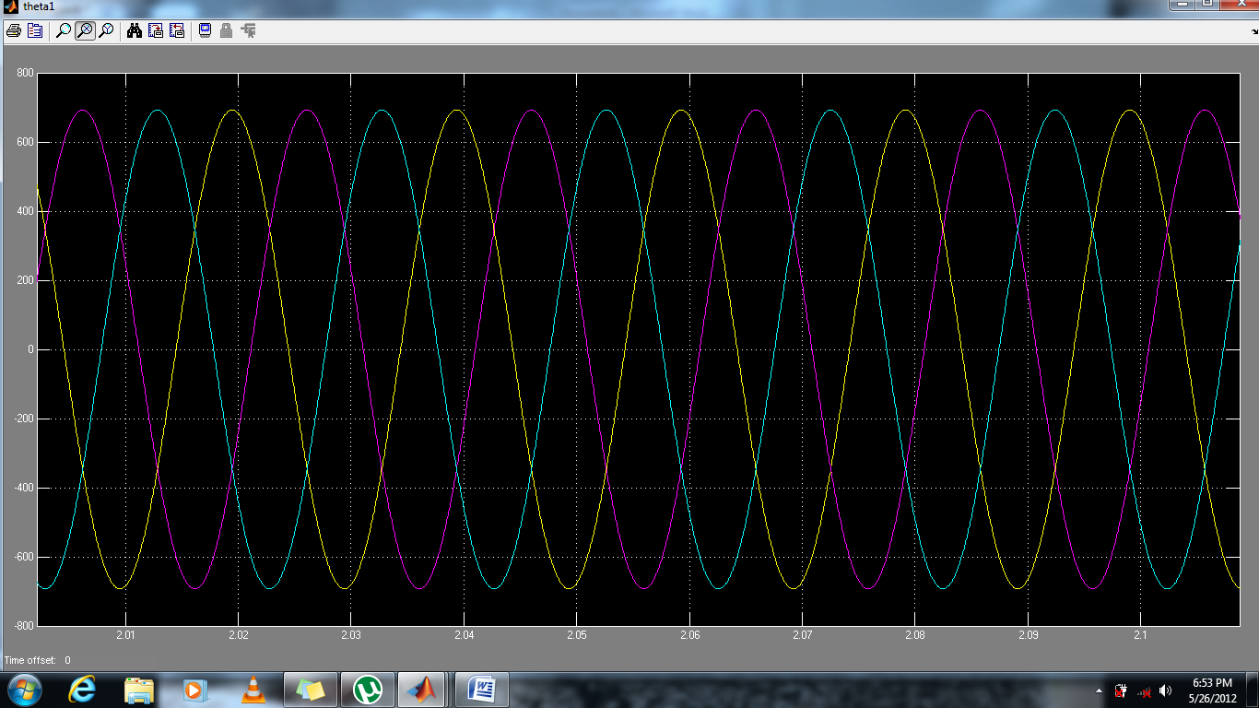

**Curve for voltage obtained from three phase inverter:**

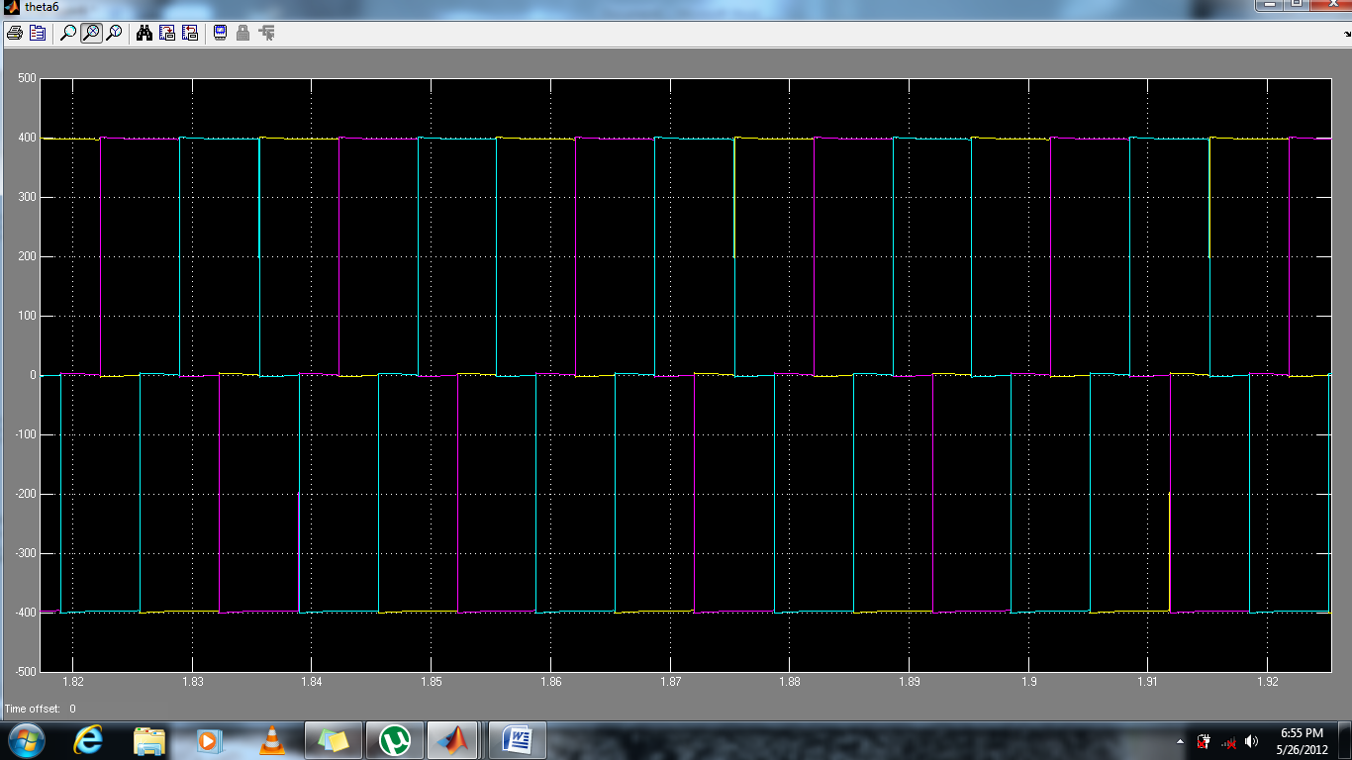

**Curve for Rotor Currents**

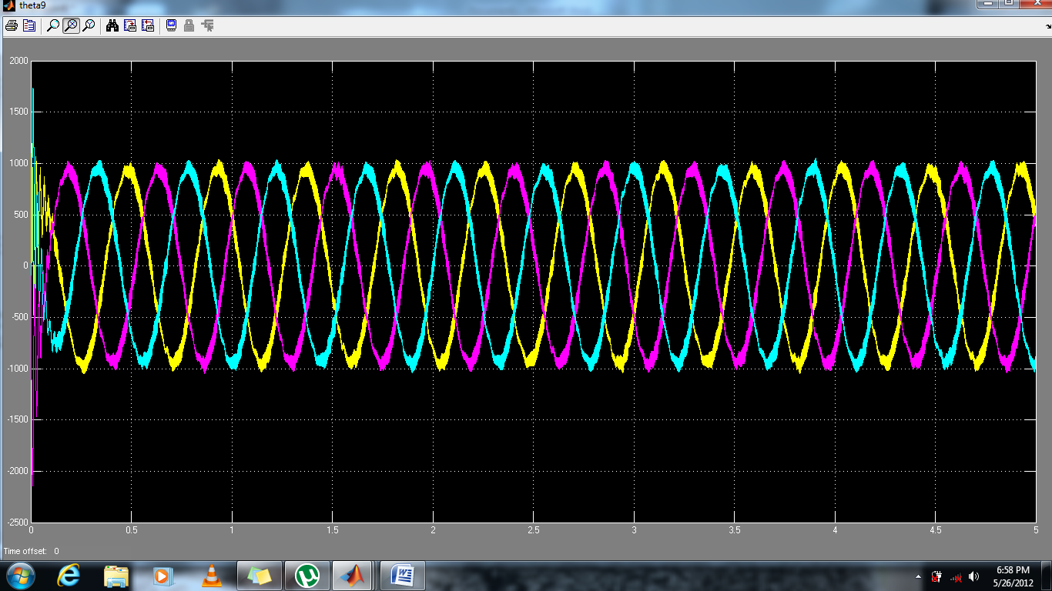

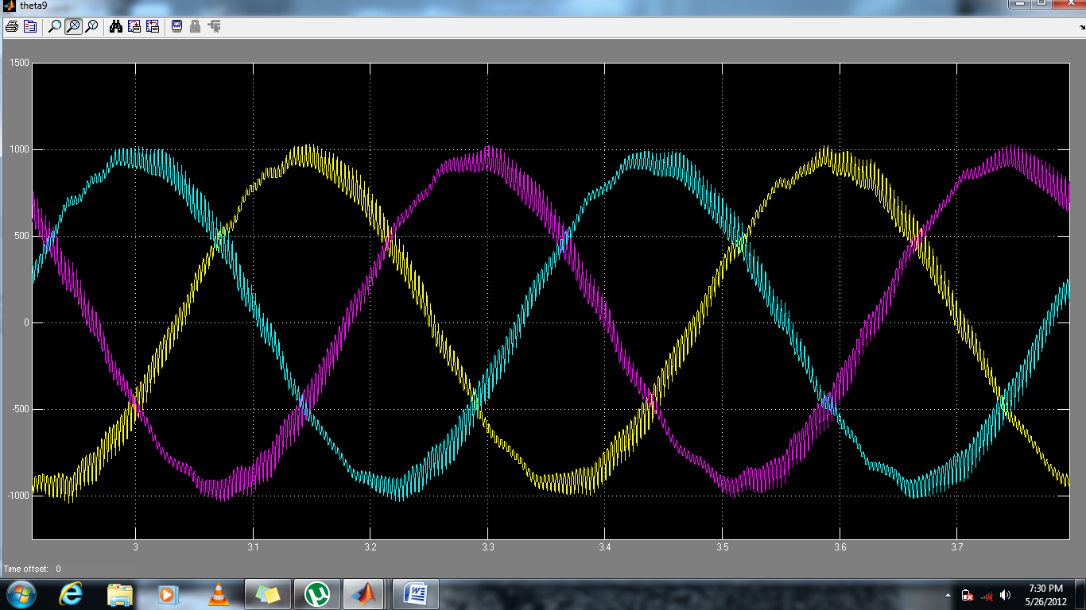

**Curve for Stator Current**

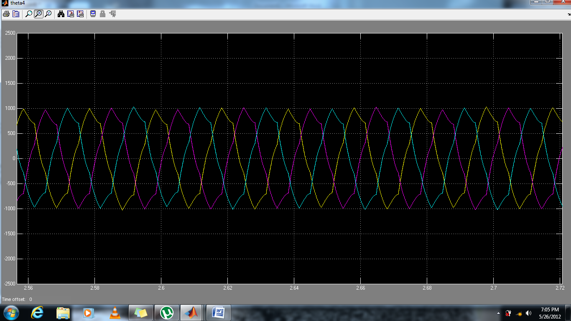

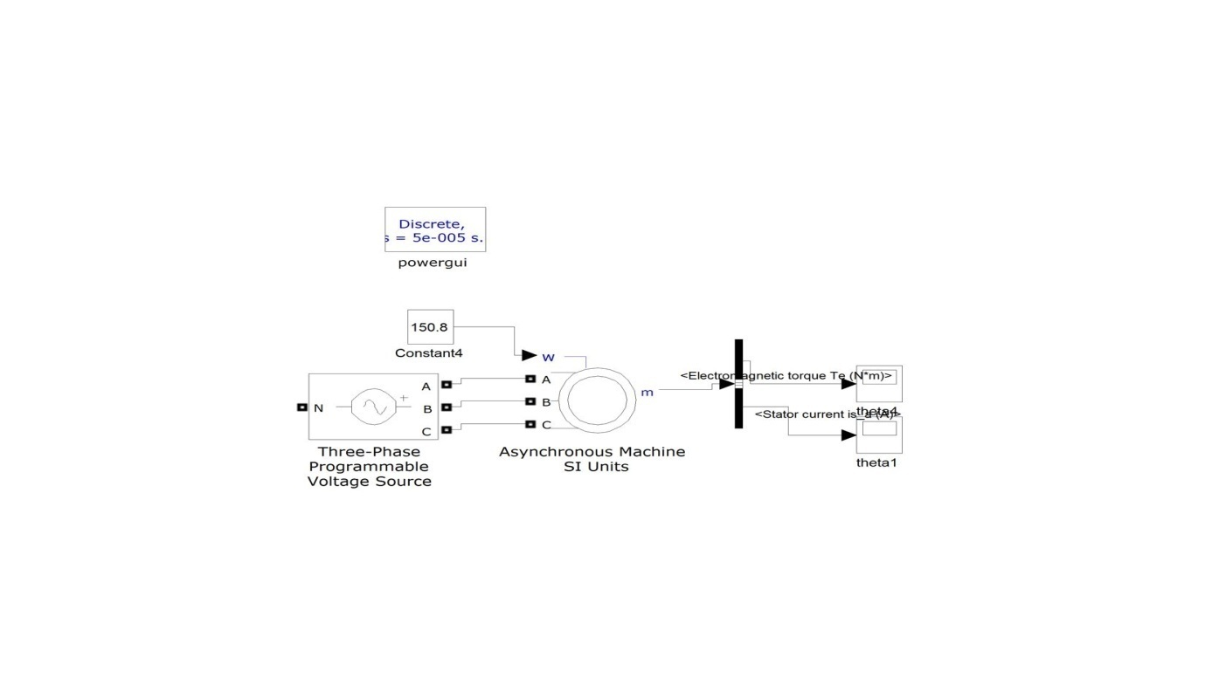

**Ideal Curve for Torque obtained from a three phase sinusoidal supply:**

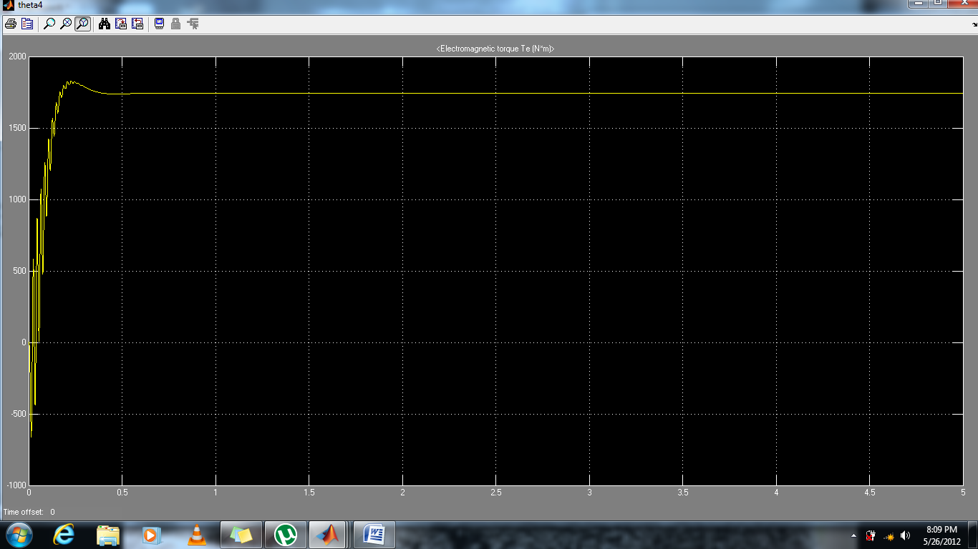

**Actual Torque obtained after Feedback:**

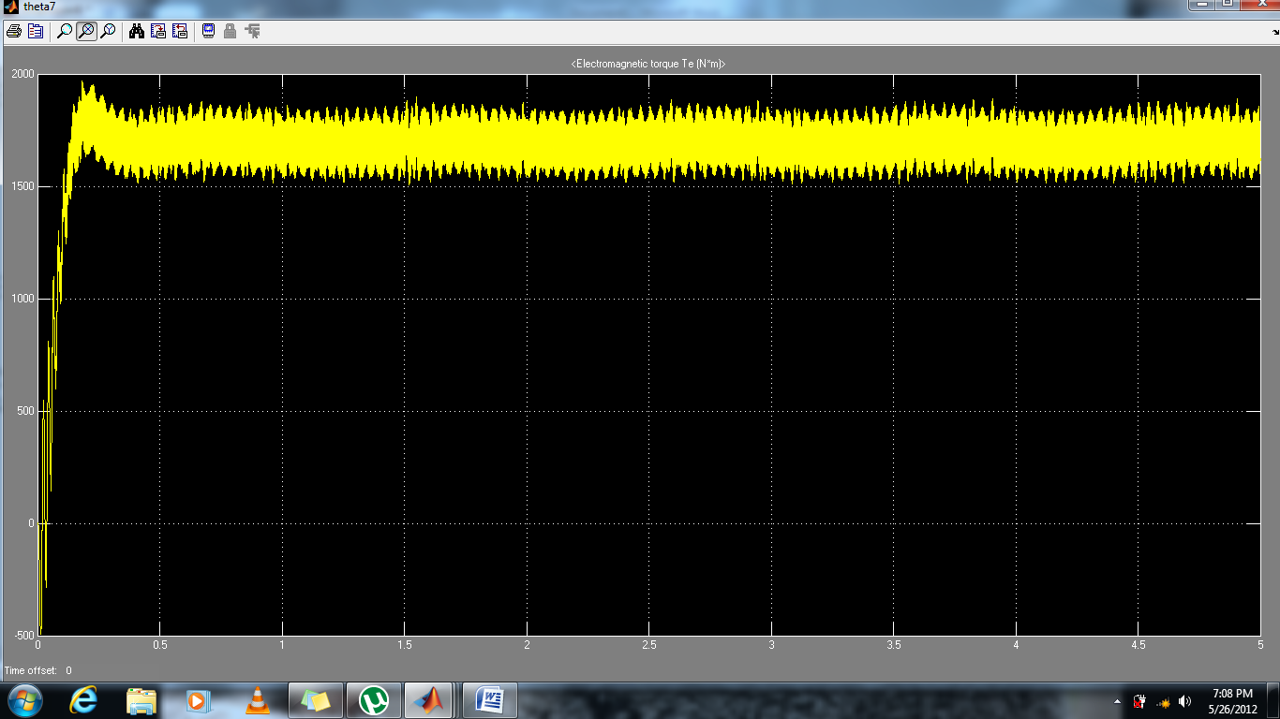

Torque output is noisy because the three-phase voltage wave is not a pure sinusoid. But due to the high inertia of the machine it will not be able to respond to such fast

**Changes and will operate at the average value of the torque as shown below:**

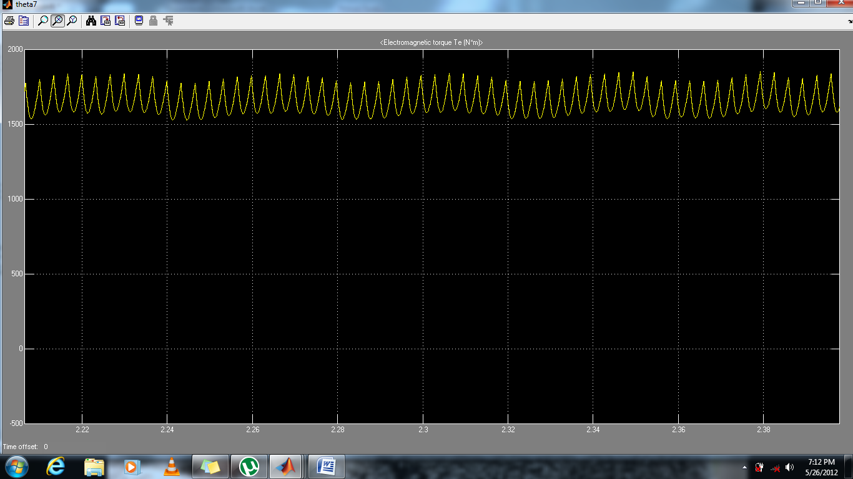

**Calculation Parameters**

**Motor parameters used for calculations**

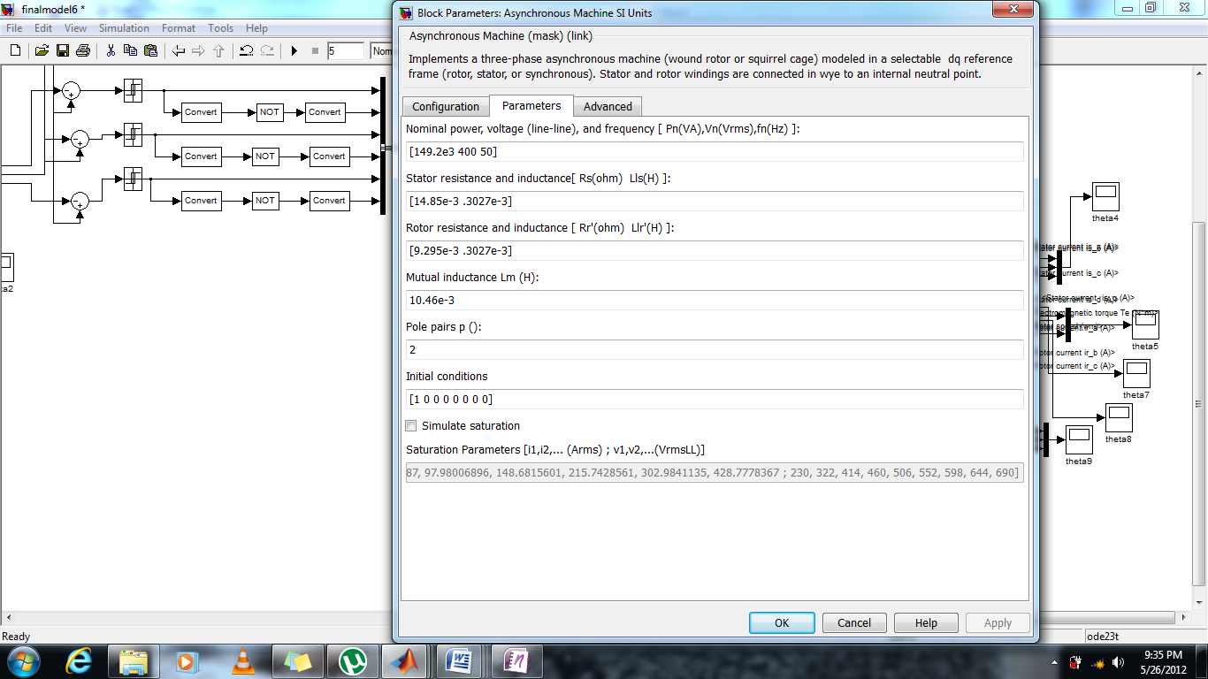

Various calculations done in model

Iqe=( (1108*s^3 + 3.38e004*s^2 + 4.003e004*s - 3.349e007)/(s^4 - 0.1335*s^3 + 2.471e004*s^2 - 1268*s + 9.756e005));

Ide=(( -1.74e005*s^2 - 5.53e006*s - 6.725e006)/ (s^4 - 0.1335*s^3 + 2.471e004*s^2 - 1268*s + 9.756e005));

PSIr=Lm*Ide/(1+(Lr/Rr)*s) ; IqestarintoPSIr=2*Lr*Te/(3*p*Lm)

PSIrstar=.5/s-PSIr ; omegarintoPSIr= Lm*Iqe/(Lr/Rr);

**Conclusion**

By successful study of constant speed operation of the induction motor drive we were able to develop an approach by which the characteristics of an induction motor can be studied at any given speed. With varying the frequency the synchronous speed changes and changes the value of currents obtained by the 4X4 matrix describing the dynamic state of an induction motor.

Some important points have to be noted which have been implemented to simplify the control of the induction motor.

* Rotor flux PSIr=Lm*Ide/(1+Tr*s) where we have taken the exponential decay as it helps in the stability.
* Iqe=2*Lr*Te*/(3*p*Lm*PSIr) we have assumed a change in electromagnetic torque of 100 N-m, all the other values we know, therefore for this change in torque we can find the change in current along the Q axis.
* Ide*=(1/Lm) *(Ki/s+Kp)((bs*nf/N)-PSIr) where

bs= nominal machine flux

nf=speed cutoff frequency

all other values are known therefore we can compute the value of Ide* that is the change in current along the d axis.

* For measuring the slip speed we have used Bernoulli’s differential equation whose derivation has been described in detail in the topic of indirect vector control
* By using feedforward vector control in which we have taken PSIqr=0.

This helps in decoupling and thus helps in finding ωslip by ODE.

* It is important to note that we have studied the feedback circuit under the rotating frame where sinusoidal voltages become stationary, but to actually operate the motor we have to use inverse park and inverse Clarke transformation for conversion into a stationary frame of reference.
* We have used saturation blocks to limit the value of transients in system. Although an accurate model with no errors in the switching times does not face any transient disturbance.
* We have used SR flipflops to generate triggering signals but that is only the case when we have to provide a digital interface, for the case of mere simulation the signals coming out from the relay can also be used as gating signals.
* The output frequency is 50 Hz which is a testament to the correctness of the model obtained; also there is no variation in the output frequency as there are no transients.
* This model can be realized in a real life situation, but it has to made sure that it has a lowpass filter for less noisy operation.

**References**

* *D-q axis dynamics-Modern* *Power Electronics and AC Drives Bimal K. Bose.*
* *Indirect or Feedforward control by- Power Electronics and AC Drives*

*Bimal K. Bose.*

* *New Transfer Function Model for PWM Power Converter by Guijun yao and Lars norum, members IEEE.*